Simulation of Contact Tracing and Isolation Using CovidSIMVL

December 20, 2020

Introduction

Using the SARS-2 viral temporal dynamics of Xi, He [*Nature Science April 2020*], incubation lasts 2.9days following infection, pre-symptomatic transmission then goes till onset of symptoms at 5.2 days, which lasts till 13.2 days at which time viral transmission is neglible.

This model has been incorporated with stochastic elements in CovidSIMVL, which is an agent-based simulation model that can generate specific situations so that the consequent dynamics can be observed closely.

The hypothesis addressed in this project is to understand quantitatively the early removal of symptomatic transmitters from circulation in the general population. The intuition to be tested is that early removal of transmitters reduces the total number of downstream infections.

Methodology

We use a sample population of 100, and initial condition of one transmitter, in a fixed arena of 800x600 pixels, in which the agents have an initial Hazard Radius stochastically centered around 5 pixels, affected by the viral state. The agents share a common movement parameter called Mingle Factor (‘mF”) which will be altered in the trials.

Each trial proceeds with the agents making movements in space based on a Pareto (negative binomial type) distribution, modified by the mingle Factor and viral load, such that an overlap between a transmitting agent and a susceptible causes viral load transfer.

The agent states go from susceptible to incubating to pre-symptomatic transmitting to symptomatic transmitting to inert (with colors of green, yellow, blue, red, and orange in correspondence). When no more transmitters are present, the trial is terminated, and the count of susceptible remaining are recorded.

Results

The standard out-of-box defaults for CovidSIMVL using a single Universe is 100 agents, Hazard Radius 5, mF=1 and temporal dynamics as in the Xi model, with symptomatic cases continuing to circulate in the population.

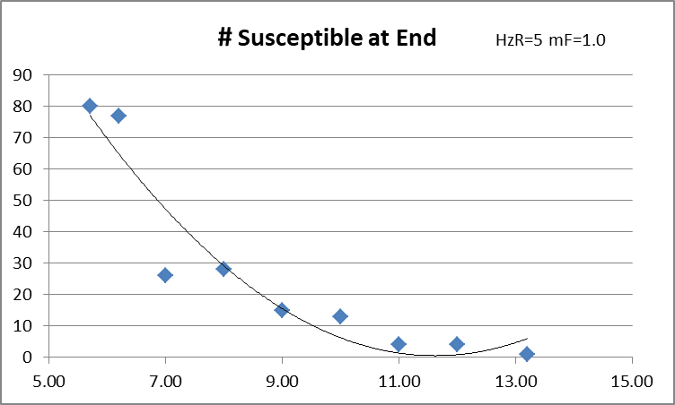

The # Susceptibles at End in this parameter set show a gradual increase from zero to 25 as we cause symptomatic cases to transition to inert from 13.2 days after infection to 7 days after infection. However, there is a big jump to near 80 susceptibles from 7 days to 6 days.

We interpret this as being due to the effect of removing transmitters from day 6 to day 13 as minor. In other words the underlying dynamics are aggressive enough that removing these transmitters does not prevent the others from finding susceptibles. At some point T, the symptomatic cases may be aged from 5.2 days (when symptoms occur) to the count at T. Restricting these transmitters to the period 5.2 to T is not sufficient to dampen the overall transmission to create a large reduction in total transmissions.

The large effect comes when the symptomatic transmission period is at 6 days, giving a total of 6 – 5.2 days of transmission. The overall situation is that the parameters reflect an aggressive epidemic.

The next set of charts show the initial conditions of HzR=5 and mF=0.6. This reduction in mobility will affect the likelihood of agents overlapping others, and thus a reduction in the intensity of the epidemic. With these settings, we run trials reducing the period of transmission of symptomatic cases.

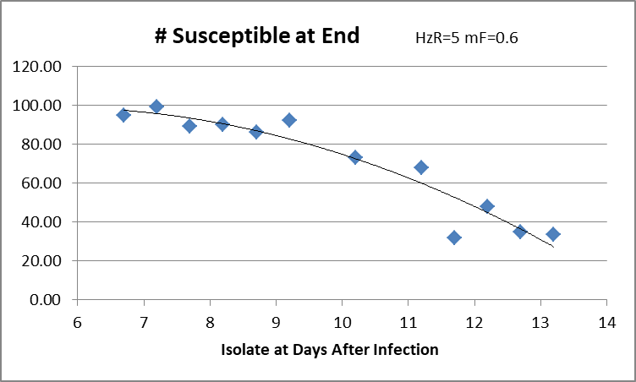

This relationship is more continuous than the other, showing that the dynamics at this level of the parameter settings are more uniform, in that the fewer days of transmission, the more the susceptibles.

The difference in practical terms is that if the epidemic that one is experiencing has aggressive dynamics, there is a small window in which removing transmitters early will create benefits in sparing susceptibles. Of course, we are always just facing the epidemics that we have. Nevertheless, epidemic dynamics due to Covid-19 are not the same everywhere. The population’s tendency to mingle, to use mitigations determines the speed and intensity of spread.

Contact Tracing

In the study above, the action was to make a transmitter inert by removing them from circulation in the population. This may be isolation, hospitalization, quarantine. The action needs to be taken, and we have assumed above the identification at onset of symptoms.

With the ideal contact tracing methodology, one can identify and test, or just identify and isolate, those persons who are in the pre-symptomatic part of the viral temporal dynamics. This is between days 2.9 and 5.2, and if these persons are tested positive as transmitters, or indeed are isolated, this will reduce the net total transmission-days even further, resulting in more susceptibles spared.

The following chart shows the impact of reducing transmitters in the pre-symptomatic period for an aggressive epidemic with HzR of 7 and mF 1.5. This setting eliminates all susceptibles in 693 generations with an R0 of 3.41 while HzR=5 and mF=1 does the same in 1114 generations with an R0 of 2.02. We remove the pre-symptomatic from circulation by changing their duration as a pre-symptomatic and setting the symptomatic day of isolation to the same day.

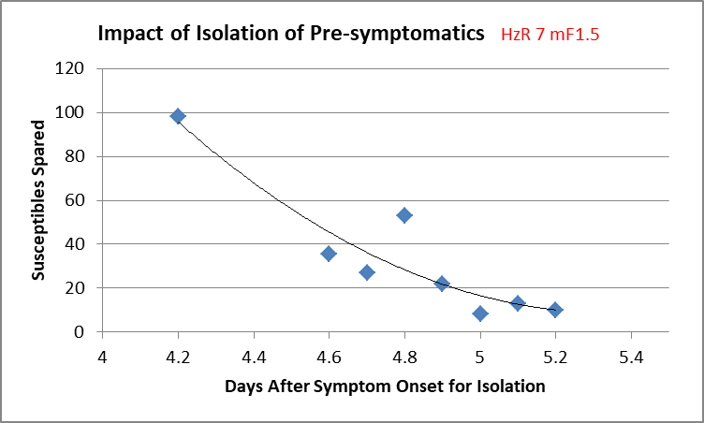

What we see is that with this level of intensity, if the pre-symptomatic alone were the transmitters (all removed at day 5.2) the number of susceptibles spared would be about 10. If contact tracing were able to identify and isolate the pre-symptomatic at day 4.2 after infection, the number of susceptibles would be near the total of them. However, the window for large benefits in the simulation is small, for only half a day…from 4.2 to 4.6. The potential benefit of near 100% sparing comes down to only 10% at isolating on day 5.2 post-infection in this model.

Below 4.2 days, eg 3.7 days post-infection, the duration of transmissibility is so small that in most trials no contagion of another agent happened.

Discussion

This simulation model shows quantitatively what we have intuition about – that removing transmitters from the population will reduce the total number infected.

We have simulated the effects of isolating symptomatic early in expansive epidemics, with a smaller window of benefit early in the symptomatic period if the epidemic is aggressive. In slower epidemics, we have a more linear relationship between days of symptoms before isolation, and the sparing of susceptibles in the population.

Finally, we show that even in very aggressive epidemics, isolating in the pre-symptomatic period can produce large benefits for susceptibles, but the window of opportunity is small.

The reason for the size of window has to do with the growth of the chains of transmission. In aggressive epidemics, more simultaneous transmitters get generated quickly, so that if the number isolated (removed) in one generation is smaller than the transmissions (infections) that they created in their previous histories to their time of isolation, the epidemic grows. The maximum effect of isolation is early, before multiplicative effects occur.

CovidSIMV is a simulation model of situations as they might exist in the real but accidental world. It is not a predictive model in the sense that tomorrow’s events are estimated from today’s events given the past history of days. Rather, it permits the observer to peer into the box in utmost detail, changing parameters and settings to observe interaction effects, something that cannot be done in the world as we know it, which is in epidemics, a particular and immutable chain of events.

From this point of view, CovidSIMVL as a simulation model, permits us to quantify the effects of early intervention in various intensities of epidemics.

APPPENDIX. TABLES OF DATA FOR THE CHARTS

 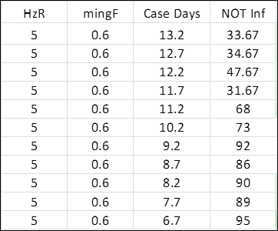

Hazard Radius = 5 Mingle Factor = 1 Hazard Radius = 5 Mingle Factor=0.6



Isolation of pre-symptomatic through ideal contact tracing